**Project Planning Phase**

**Project Planning Template (Product Backlog, Sprint Planning, Stories, Story points)**

|  |  |
| --- | --- |
| Date | 23 October 2022 |
| Team ID | PNT2022TMID48076 |
| Project Name | REAL TIME RIVER WATER QUALITY MONITORING AND CONTROL SYSTEM |
| Maximum Marks | 8 Marks |

**Product Backlog, Sprint Schedule, and Estimation (4 Marks)**

create product backlog and sprint schedule

| **Sprint** | **Functional Requirement (Epic)** | **User Story Number** | **User Story / Task** | **Story Points** | **Priority** | **Team Members** |
| --- | --- | --- | --- | --- | --- | --- |
| Sprint-1 | Registration | USN-1 | As a user, I can register for the application by entering my email, password, and confirming my password. | 5 | High | KARTHIGA.C |
| Sprint-1 |  | USN-2 | As a user, I will receive confirmation email once I have registered for the application | 5 | High | DHANAM.S |
| Sprint-2 |  | USN-3 | As a user, I can register for the application through Facebook | 3 | Low | S.SOLAI NANDHINI |
| Sprint-1 |  | USN-4 | As a user, I can register for the application through Gmail | 2 | Medium | K.VINMATHI |
| Sprint-1 | Login | USN-5 | As a user, I can log into the application by entering email & password | 3 | High | SANGEETHA.S |
| Sprint-3 | Notification | UNS-6 | When river water has dust particles it notify mobile app. | 6 | High | KARTHIGA.C |
| Sprint-4 | notification | USN-7 | When river water is quality to use it notify to user | 6 | High | SANGEETHA.S |

**Sprint delivery chart using Jira software tools**

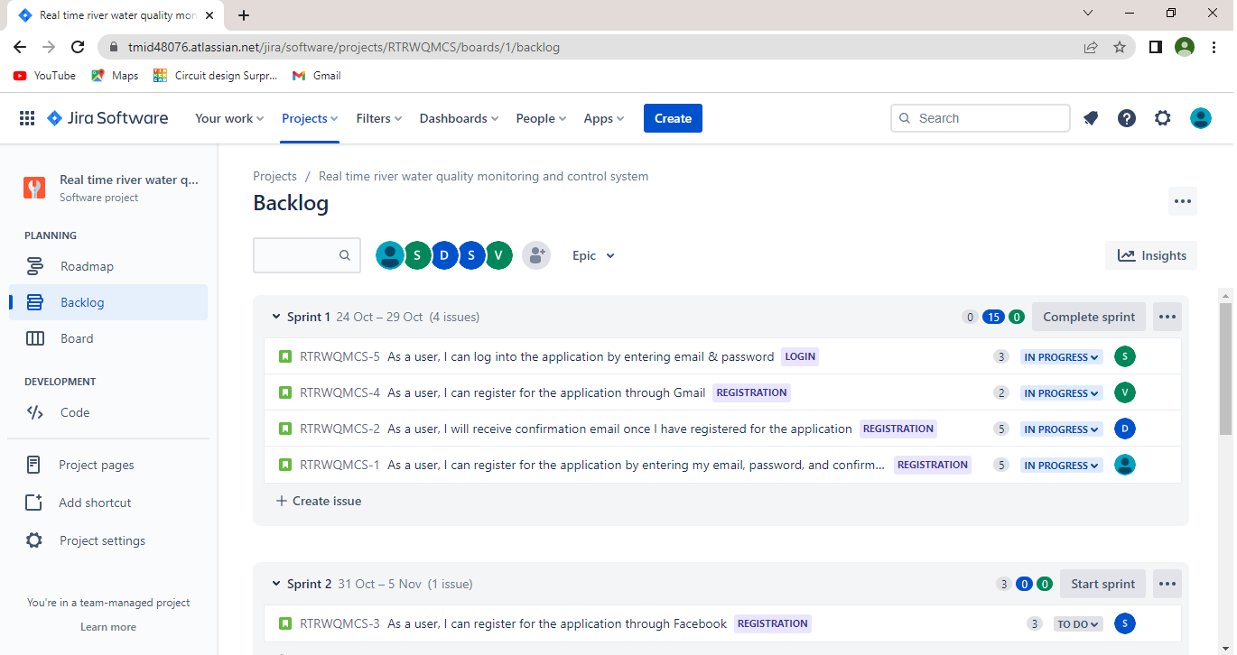

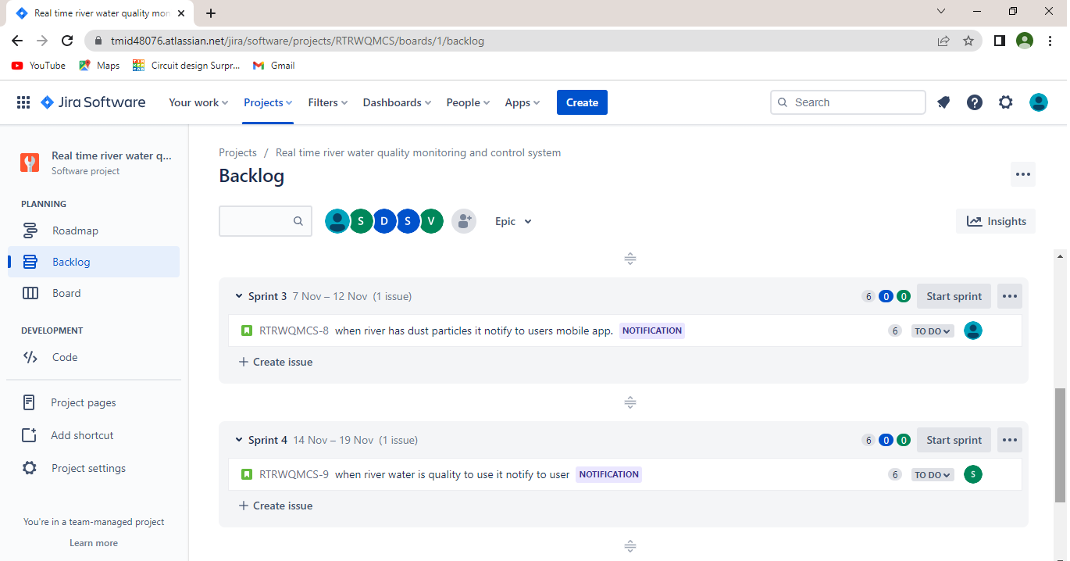

**Project Tracker, Velocity & Burndown Chart: (4 Marks)**

| **Sprint** | **Total Story Points** | **Duration** | **Sprint Start Date** | **Sprint End Date (Planned)** | **Story Points Completed (as on Planned End Date)** | **Sprint Release Date (Actual)** |
| --- | --- | --- | --- | --- | --- | --- |
| Sprint-1 | 20 | 6 Days | 24 Oct 2022 | 29 Oct 2022 | 20 | 28 Oct 2022 |
| Sprint-2 | 20 | 6 Days | 31 Oct 2022 | 05 Nov 2022 | 20 | 04 Nov 2022 |
| Sprint-3 | 20 | 6 Days | 07 Nov 2022 | 12 Nov 2022 | 20 | 11 Nov 2022 |
| Sprint-4 | 20 | 6 Days | 14 Nov 2022 | 19 Nov 2022 | 20 | 19Nov 2022 |

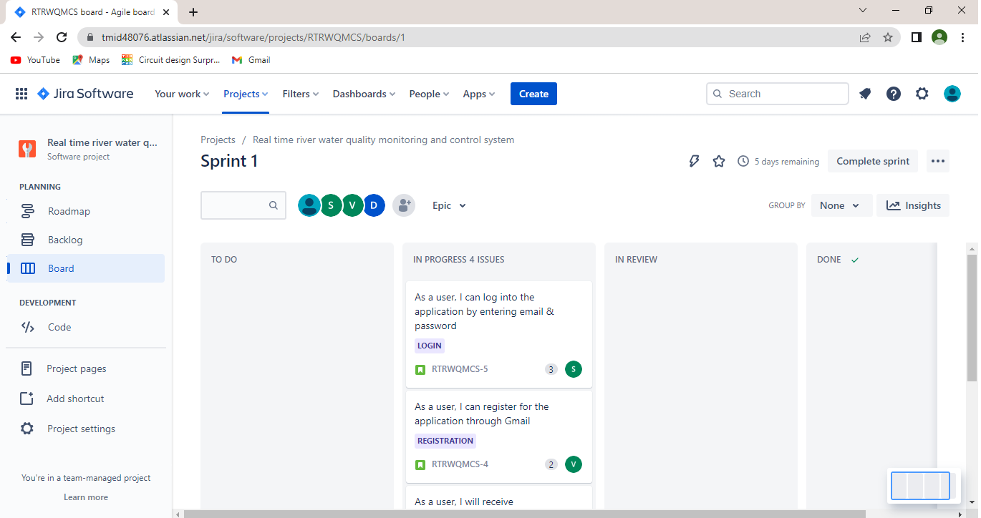

**Velocity:**

Imagine we have a 10-day sprint duration, and the velocity of the team is 20 (points per sprint). Let’s calculate the team’s average velocity (AV) per iteration unit (story points per day)



ROAD MAP:

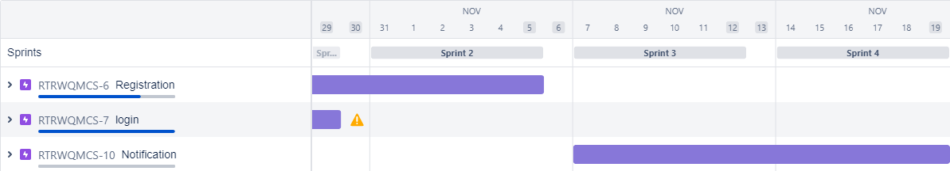

**Burndown Chart:** A burn down chart is a graphical representation of work left to do versus time. It is often used in agile[software development](https://www.visual-paradigm.com/scrum/what-is-agile-software-development/) methodologies such as [Scrum](https://www.visual-paradigm.com/scrum/scrum-in-3-minutes/). However, burn down charts can be applied to any project containing measurable progress over time.